CLEO BOT USER GUIDE

Instructions.

- Tell Cleo you’d like to book a room
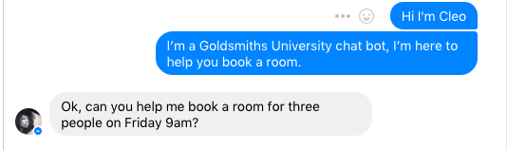

- You will be sent a security code by Cleo that you need to confirm
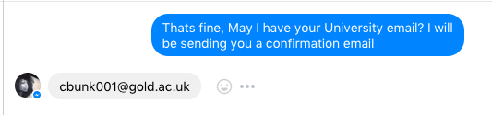
- You need to confirm to Cleo you have received the code by repeating the code back to Cleo
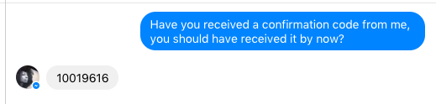

- After this, provide Cleo with what kind of room you would want.
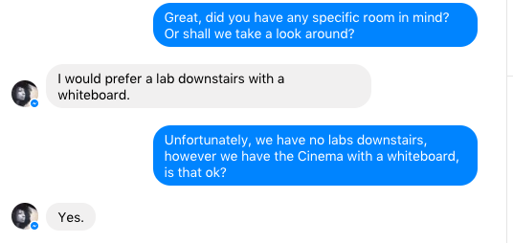
- Please provide Cleo with a time you would like to book
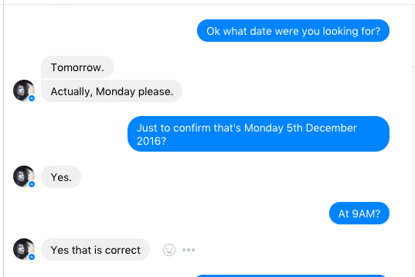
- Please inform Cleo how many hours youd like to stay in the room for.
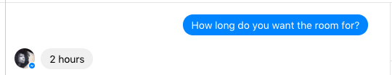
- Cleo will confirm your booking with you
